Description of toweddemo.mov

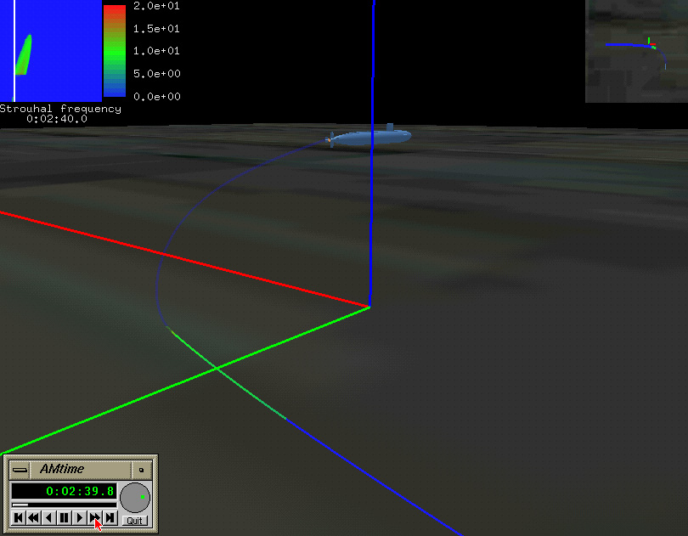

- A simulation was performed off-line of a Los Angeles (688) class sub streaming out a 3700 ft line consisting of a 1000 ft tow cable attached to a 2700 ft towed sonar array. There are three DIVERSE applications which communicate via shared memory to render the scene: 1) a controller which sets the simulation time of interest, 2) a database server which interpolates to obtain the data sets corresponding to a give time, and 3) a renderer which displays that has been retrieved by the database server.
- The renderer displays the sub and towed array and utilizes the standard DIVERSE navigation services. The tow cable is rendered as a transparent line; the sonar array as a solid line. Both sections are colored according to the selected data set, which the corner the user may cycle through dynamically by a mouse button push. In the upper right hand corner is an inset God’s-eye view. In the upper left is a representation of the displayed data set for the entire array and time of the run, color-coded according to the adjacent legend, with the current time indicated by a vertical line. In the lower right is the VCR-style time controller window superimposed over the renderer window: it is not currently an integral part of the renderer.
- In this movie, the sub starts executing a 90 degree turn to starboard when the sub center of gravity coincides with the corrdiante origin. Mouse clicks are shown that start, pause, and re-start simulation time. The various data sets are cycled through, indicated by the inset in the upper left and the re-coloring of the towed array. The horizontal valuator of the VCR controller is selected and dragged left and right to quickly select a time of interest.
- The data set of special interest is the Strouhal frequency, a nondimensionalized vortex shedding frequency. A high Strouhal frequency is indicative of a high level of self noise. In the movie, an array element colored anything but blue is shedding vortices: any useful signal reaching it is overwhelmed by the resultant noise level.
- The ability to accurately process data sensed by a towed array is dependent on knowing the position, orientation, and self-noise of each of its elements. The capability to visualize the simulation of a submarine maneuvering with a towed array deployed will improve this processing ability.

